Session 6
Aim
To study process states, process termination , zombie and orphan processes , and non-preemptive CPU scheduling.
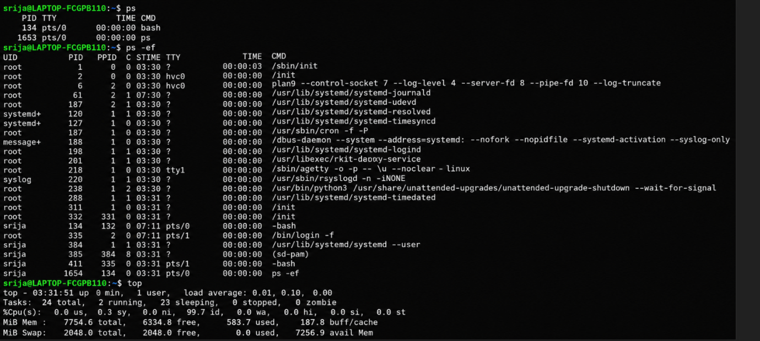
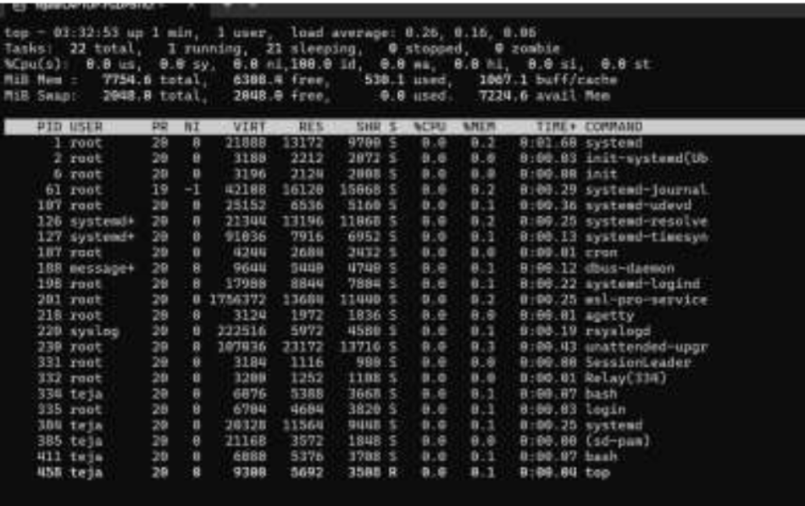
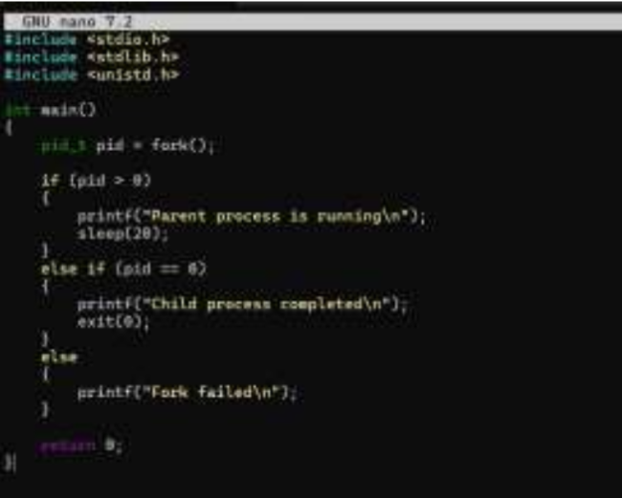
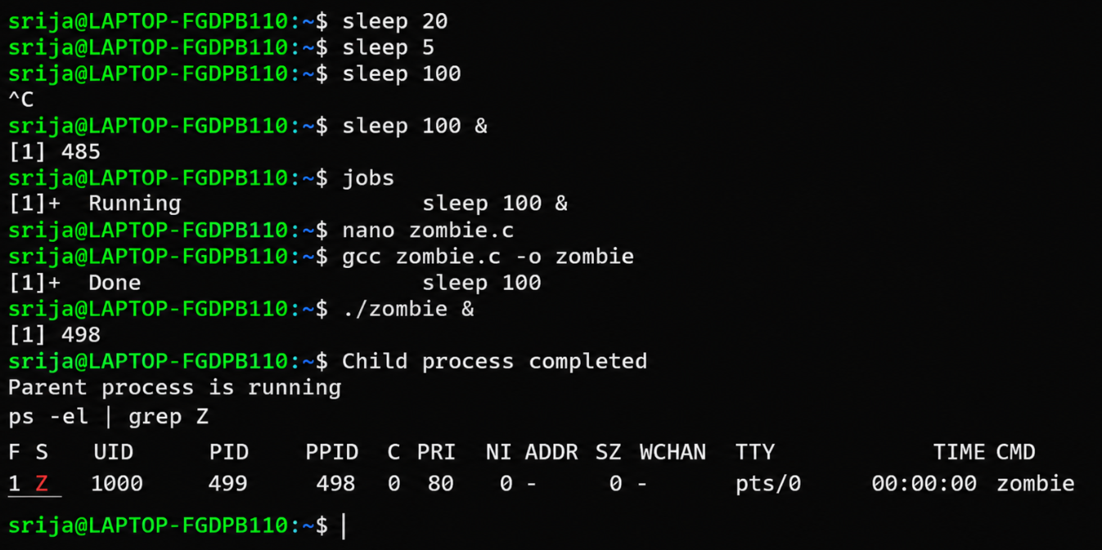
Short theory
A zombie process is a child process that has completed its work, but its parent has not collected its exit status. It remains temporarily in the process table.
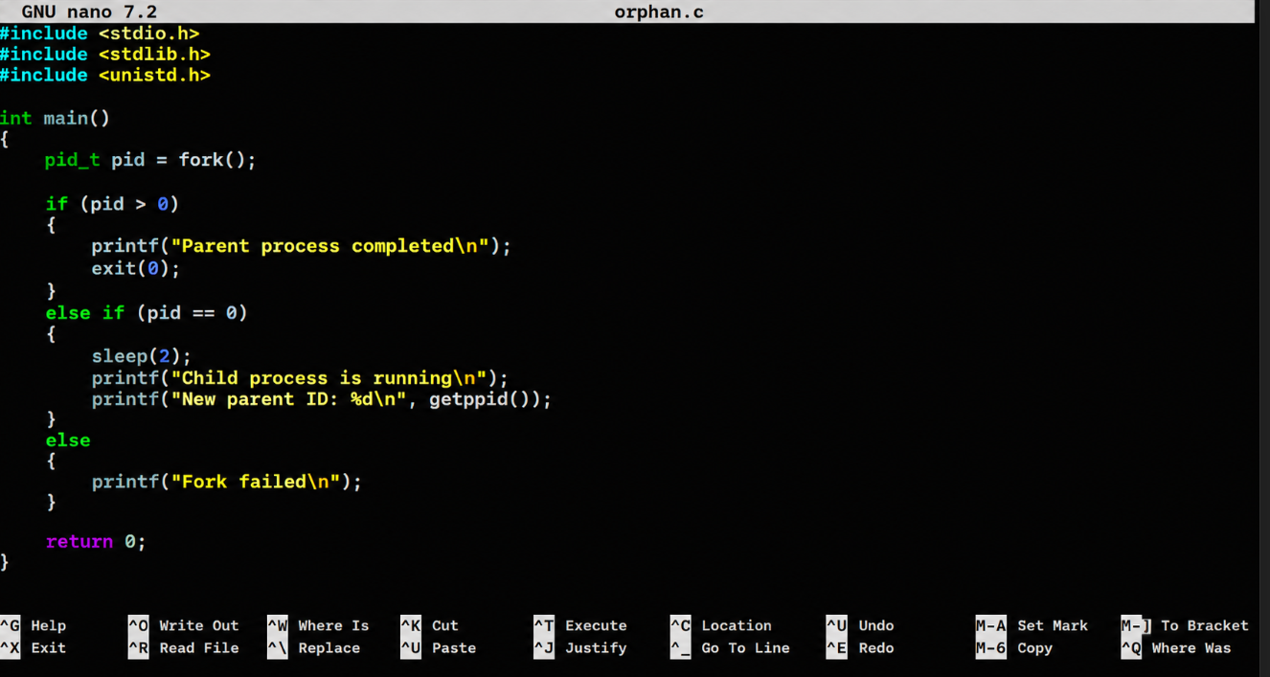
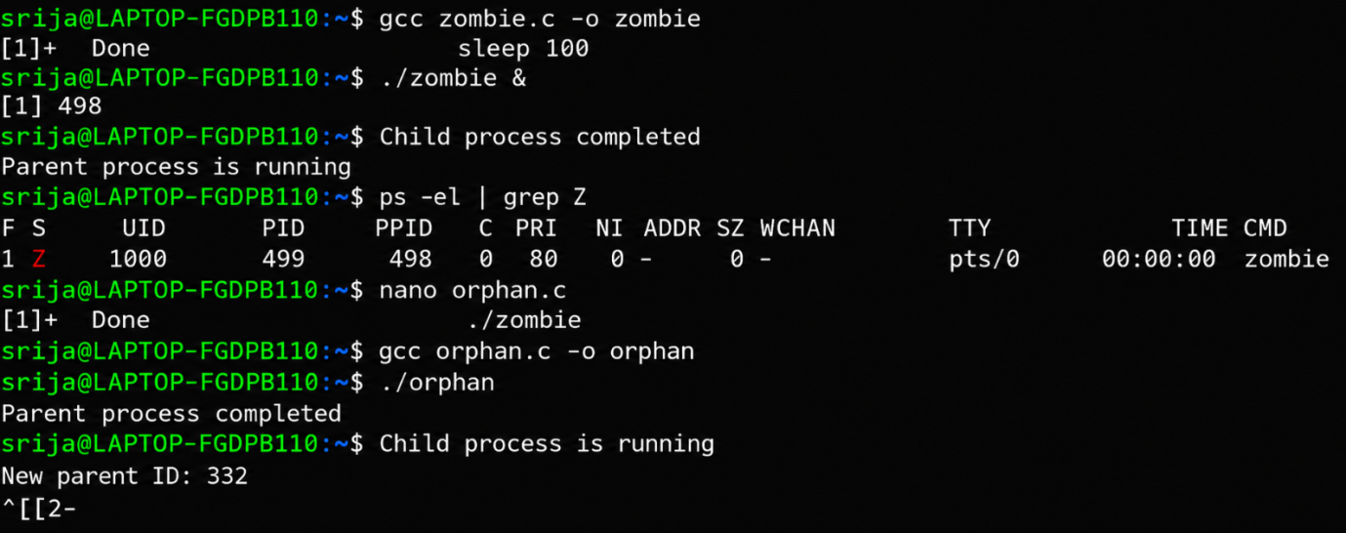
Short theory
An orphan process is a child process whose parent terminates before the cild. The operating system assigns the child to another system process.
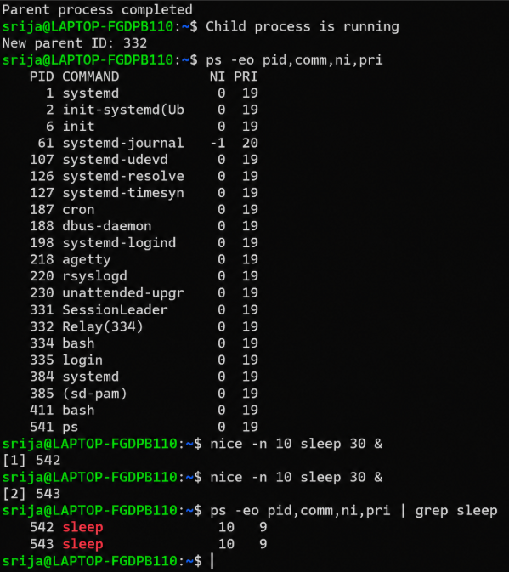
Session 6 short theory
In this session, we studied process states and process termination. We observed waiting processes using sleep, normal and abnormal termination. zombie processes and orphan processes. We also observed process priority. CPU scheduling helps the operating system.

